Statistics and Data – Lesson 2A.01D
Society – Displaying Data.

Name: _________________
- Display the shopping order below as a column graph:
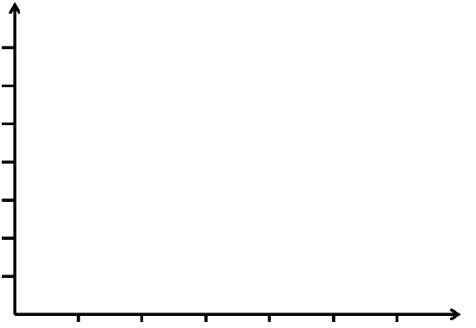
Item | Frequency
Apple | 3
Banana | 4
Mango | 6
Orange | 7
Peach | 6
Pear | 2

- Draw a line graph for the monthly mean maximum and mean minimum Temperatures for Port Macquarie. [www.weatherzone.com.au/climate/station.jsp?lt=site&lc=60139]

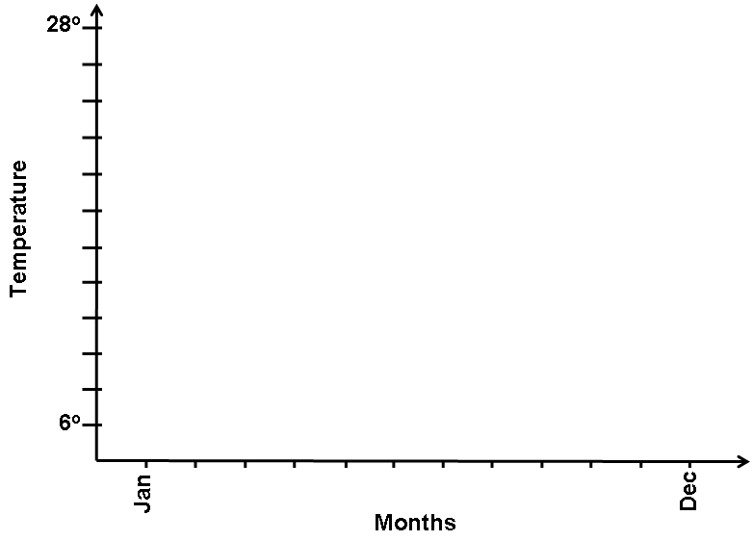

- Take two coins and toss about 20 times to make a dot plot below.

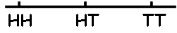
- Plot a Histogram for the median rain (mm) for Port Macquarie. [www.weatherzone.com.au/climate/station.jsp?lt=site&lc=60139]

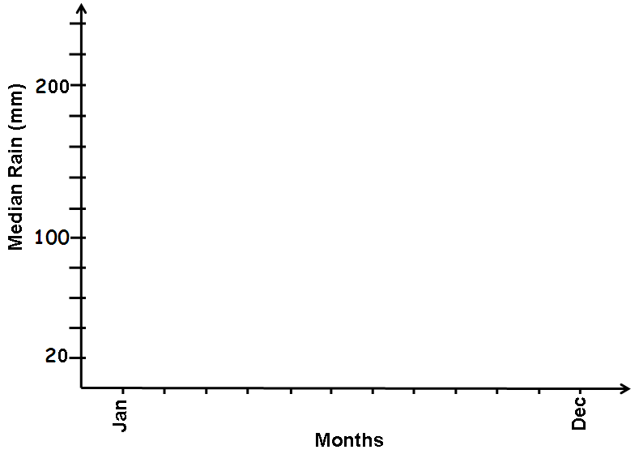

Why were the Sydney Olympics held in September?

- A Pet Shop has 20 red finches, 30 yellow finches and 40 blue finches. Display this in a pie chart (i.e. sector graph). You need to find the angles and use a protractor.
20
90
Red Finches = x 360º = 80º Yellow Finches =

Blue Finches =

