Financial Mathematics – Lesson 1A.06A
Earning & Managing Money – Piece Work

Name: _________________

- What is piece work? ? (Google ‘Define: Piecework’)

- How does this differ from a wage?

- What industries use piecework?

- Piece Work – a play by Miriam Packer written in 1997. (138 pages)

Set in Montreal in the early 1980s, Piece Work is a full-length play about six women who work together in a clothing factory and are paid by the piece. Unable to confront the factory owner who exploits them, the women turn on each other instead, venting their frustrations and hostility, giving way to inner-directed rage. When one of the workers has an accident and is taken into hospital, the women begin to channel their energies towards positive action and to address the real source of the problem -- the employer. Then learn the power that comes out of unity. Piece Work is a play about gaining voice and visibility, and about acceptance -- of self and of others. (Google Books)

How does this make you feel about piece work?

- A wooden toymaker is paid $12 for each train he makes. If he makes 20 trains then how much is he paid?

- John can strip pick 3 bins of apricots per day. (1 bin = 22 cases of fruit)

  - How much does he earn per day? (http://www.corboys.com.au/wages.html).

  - How much will he earn for a five day week?


- A clothing worker is paid $3.50 per garment. If she can make 25 garments per day how much does she earn in a 5 day week?


- A worker makes 12 toffee apples and sells then for $2.50 each at the markets. How much do they earn?


- An old lady made four apple pies that she cut into eight pieces. She sold them at the church spring fair. If she sold each piece for $2, how much did she earn for the church?

- Look up ‘yard art’ on ebay and find out much they charge per item.


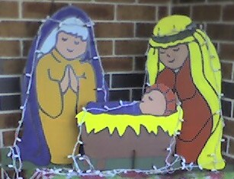
- A man sells nativity yard art at $30 per piece. How much does he earn for the 3 pieces Mary, Joseph and baby Jesus?

- An Indonesian Nike shoe worker is paid 12 cents per pair made. If he makes 112 pairs per day, how much does he earn that day?



- A Sydney mother makes 12 dresses per day. If she gets paid $5.00 per dress, how much does she get paid each day?

